PACE INSTITUTE OF TECHNOLOGY AND SCIENCES

**APPENDIX 1**

# TITLE OF PROJECT

# Soleful Steps Online Shoes Store Frontend Website

INTERNSHIP PROJECT REPORT

***by***

*Vallela Supritha*

## Vallela Supritha

(Roll Number: 22kq1a0735)

Department of Computer Science & Information Technology

PACE INSTITUTE OF TECHNOLOGY AND SCIENCES

Ongole

June-2024

**APPENDIX 2**

## BONAFIDE CERTIFICATE

This is to certify that this project report entitled **Soleful Steps Online Shoes Store Frontend Website** submitted to **PACE Institute of Technology and Sciences**,is a bonafide record of work done by

**Vallela Supritha** under my supervision from **20-05-2024** to **12-06-2024 .**

Signature

Mr. Kasireddy Rama kumar

Place :Ongole

Date :10-06-2024

APPENDIX 3

## Declaration by Author

This is to declare that this report has been written by me/us. No part of the report is plagiarized from other sources. All information included from other sources have been duly acknowledged. I/We aver that if any part of the report is found to be plagiarized, I/we are shall take full responsibility for it.



Vallela Supritha

Roll number: 22KQ1A0735

Place :Ongole

Date :10-06-2024

### APPENDIX 4

### TABLE OF CONTENTS

**CHAPTER NO. TITLE PAGE NO.**

**ABSTRACT iii**

**CONTENTS xx**

1. **Introduction .......................................................................... 1**
2. **Abstract ................................................................................. 2**
3. **Methodology .......................................................................... 3**
4. **Result ...................................................................................... 4**
5. **Conclusion .............................................................................. 5**
6. **Future Work ........................................................................... 7**

# 1.Introduction

* + Welcome to our shoe store, where fashion meets comfort and style. At Soleful steps shoes store. we strive to provide you with the perfect pair of shoes for any occasion. Here's a glimpse of what we offer:
  + Extensive collection of footwear for men.
  + Trendy designs crafted with quality materials
  + Wide range of sizes to ensure the perfect fit for everyone
  + Specialized styles for athletic activities, casual outings, and formal events
  + Exceptional customer service to assist you in finding your ideal pair
  + Step into our store and step out in style with shoes that elevate your look and enhance your comfort.

Welcome to **Soleful Steps Online Shoes Store**, where footwear meets convenience! Step into the world of effortless shoe shopping from the comfort of your own home. At Soleful steps online shoes store, we understand that finding the perfect pair of shoes can be both a necessity and a pleasure. Our online store offers a vast selection of stylish and comfortable footwear for every occasion, whether you're looking for everyday sneakers, elegant heels, rugged boots, or cozy slippers.

With our user-friendly interface and intuitive navigation, browsing through our extensive collection is a breeze. We prioritize customer satisfaction, offering high-quality shoes from trusted brands at competitive prices. Plus, our secure payment options and swift delivery ensure a seamless shopping experience from start to finish.

Say goodbye to crowded malls and long checkout lines – shop with ease and confidence at At Soleful steps online shoes store, your ultimate destination for all things footwear. Step up your shoe game today!

Welcome to Soleful Steps, where every stride tells a story! Established in 2024 in the heart of Ongole, we're your premier destination for quality footwear that blends style, comfort, and durability seamlessly.

At Soleful Steps, we understand that shoes aren't just a necessity; they're an expression of your individuality and a reflection of your journey. That's why we're dedicated to offering a curated collection of shoes that cater to every step of your life's adventure.

Whether you're strolling through the city streets, hitting the trails, or stepping into the boardroom, we've got you covered with a diverse range of styles, from classic to contemporary. From trendy sneakers to timeless boots, from elegant heels to cozy slippers, our selection is carefully curated to meet the diverse needs and tastes of our customers.

But Soleful Steps is more than just a shoe store – it's a community hub where shoe enthusiasts come together to share their passion and discover their next favorite pair. With our friendly and knowledgeable staff, shopping at Soleful Steps is not just about finding the right shoes; it's about enjoying the journey every step of the way.

So, whether you're embarking on a new adventure or simply looking to refresh your wardrobe, step into Soleful Steps and let us help you find the perfect pair to take you there. Your journey starts here.

**2.Abstract**

Soleful Steps, established in 2024 in Ongole, embodies a fusion of style, comfort, and durability in footwear retail. This premier destination offers a meticulously curated collection of shoes catering to diverse tastes and lifestyles. From urban strolls to rugged trails, from corporate corridors to cozy evenings at home, Soleful Steps provides an array of options, including trendy sneakers, timeless boots, elegant heels, and snug slippers. More than a mere retail space, Soleful Steps fosters a vibrant community where shoe aficionados converge to share their passion. With a commitment to exceptional service and product quality, Soleful Steps invites customers to embark on a journey of self-expression and exploration, one step at a time.

1**. Location and Hours**: Soleful Steps is conveniently located in the heart of Ongole, making it easily accessible for customers in the area. Our store operates during regular business hours, ensuring that you can shop for your favorite footwear at your convenience.

2**. Expert Staff**: Our team at Soleful Steps is comprised of passionate and knowledgeable individuals who are dedicated to helping you find the perfect pair of shoes. Whether you need assistance with sizing, style recommendations, or maintenance tips, our staff is here to provide expert guidance and support.

3**. Brand Partnerships** : We collaborate with a wide range of reputable brands to bring you the latest and greatest in footwear fashion. From globally recognized names to emerging designers, Soleful Steps offers a diverse selection of shoes that are both on-trend and high-quality.

4. **Online Shopping**: In addition to our physical store, Soleful Steps also offers an intuitive online shopping experience. Browse our extensive collection, place your order with ease, and enjoy fast and reliable delivery straight to your doorstep.

5. **Special Events and Promotions**: Keep an eye out for special events and promotions at Soleful Steps, where you can take advantage of exclusive discounts, limited edition releases, and exciting giveaways. Follow us on social media or subscribe to our newsletter to stay informed about upcoming sales and events.

6. **Customer Satisfaction Guarantee**: At Soleful Steps, your satisfaction is our top priority. We stand behind the quality of our products and are committed to providing exceptional customer service at every step of your shopping journey. If you have any questions, concerns, or feedback, please don't hesitate to reach out to us – we're here to help!

With its commitment to style, comfort, and community, Soleful Steps is more than just a shoe store – it's a destination where you can discover your perfect pair and step into confidence and style. Visit us today and experience the Soleful Steps difference for yourself!

**3.** **Methodology**

**Requirements:**

**Software:**

* + **HTML.**
  + **CSS.**
  + **CSS3**
  + **HTML5**
  + **JavaScript.**
  + **Bootstrap**

The methodology section of a business plan for Soleful Steps shoe store could outline how the store plans to achieve its objectives and deliver on its promises. Here's a simplified breakdown:

1.**Market Research:** Conduct thorough market research to understand customer preferences, trends, and competition in the footwear industry, both locally and globally.

2. **Supplier Selection:** Identify and establish partnerships with reputable shoe manufacturers and distributors to ensure a diverse and high-quality product range.

3. **Inventory Management**: Implement efficient inventory management systems to optimize stock levels, minimize wastage, and ensure availability of popular styles and sizes.

4. **Customer Experience**: Prioritize customer satisfaction by offering excellent service, personalized recommendations, and hassle-free shopping experiences, both online and in-store.

5. **Marketing Strategy**: Develop a comprehensive marketing strategy to raise brand awareness, attract new customers, and retain existing ones through a mix of digital marketing, social media engagement, and traditional advertising.

6. **Community Engagement**:Foster a sense of community among customers through events, promotions, and partnerships with local organizations or charities, enhancing brand loyalty and customer retention.

7. **Continuous Improvement**:Regularly review and refine business operations based on customer feedback, market trends, and performance metrics to stay competitive and meet evolving customer needs.

8. **Market Research and Analysis**:

- Conduct comprehensive market research to identify key trends, customer preferences, and competitive landscape in the footwear industry.

- Analyze demographic data, purchasing behavior, and emerging market segments to tailor product offerings and marketing strategies accordingly.

- Utilize market research tools, surveys, and focus groups to gather insights and validate business decisions.

9. **Supplier and Product Selection**:

- Establish partnerships with reputable shoe manufacturers, wholesalers, and distributors to source a diverse range of high-quality footwear.

- Negotiate favorable terms, including pricing, minimum order quantities, and exclusivity agreements, to ensure competitive pricing and product availability.

- Regularly assess product performance, customer feedback, and market demand to refine the product assortment and introduce new offerings.

10. **Inventory Management and Logistics**:

- Implement robust inventory management systems to track stock levels, monitor sales trends, and optimize replenishment schedules.

- Utilize forecasting techniques, such as demand planning and trend analysis, to anticipate customer demand and prevent stockouts or overstock situations.

- Streamline logistics operations, including warehousing, shipping, and fulfillment, to ensure timely delivery of orders and minimize operational costs.

11. **Customer Experience Enhancement**:

- Invest in staff training and development to ensure exceptional customer service, product knowledge, and problem-solving skills.

- Implement omni-channel retail strategies to provide seamless shopping experiences across online and offline channels, including mobile apps, e-commerce platforms, and brick-and-mortar stores.

- Leverage technology solutions, such as CRM systems and loyalty programs, to personalize interactions, reward customer loyalty, and drive repeat purchases.

12. **Marketing and Branding Strategies**:

- Develop a cohesive brand identity and positioning strategy that resonates with the target audience and communicates the unique value proposition of Soleful Steps.

- Create compelling marketing campaigns and promotions to generate brand awareness, drive foot traffic, and stimulate sales both online and in-store.

- Utilize a mix of digital marketing channels, including social media, email marketing, search engine optimization (SEO), and pay-per-click (PPC) advertising, to reach and engage with potential customers.

13. **Community Engagement and Social Responsibility**:

- Engage with local communities through sponsorships, partnerships, and participation in events to build brand affinity and establish goodwill.

- Incorporate sustainable and ethical business practices, such as eco-friendly packaging, fair labor standards, and charitable initiatives, to demonstrate corporate social responsibility and align with consumer values.

14. **Performance Measurement and Continuous Improvement**:

- Establish key performance indicators (KPIs) and metrics to monitor business performance, track progress against goals, and identify areas for improvement.

- Conduct regular reviews and audits of business operations, customer feedback, and market dynamics to make data-driven decisions and adapt strategies as needed.

- Foster a culture of innovation and agility, encouraging experimentation, learning, and adaptation to stay ahead of competitors and capitalize on emerging opportunities.

By implementing a systematic and strategic approach, Soleful Steps aims to build a strong brand, cultivate customer loyalty, and achieve sustainable growth in the competitive footwear market.

a structured methodology, Soleful Steps aims to establish itself as a leading destination for stylish, comfortable, and high-quality footwear, delivering value to customers and achieving sustainable growth.

**4.Result**

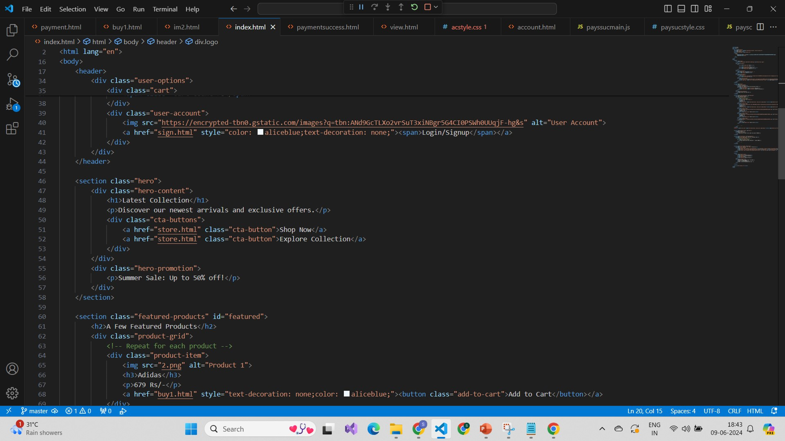



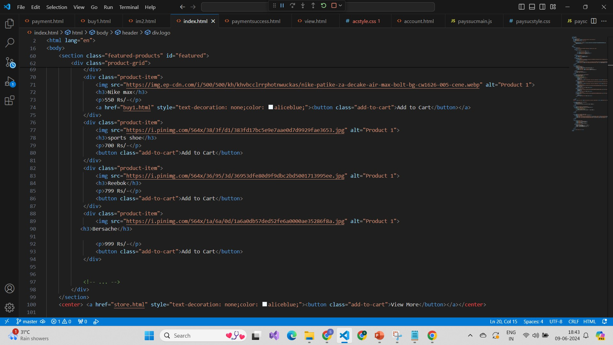

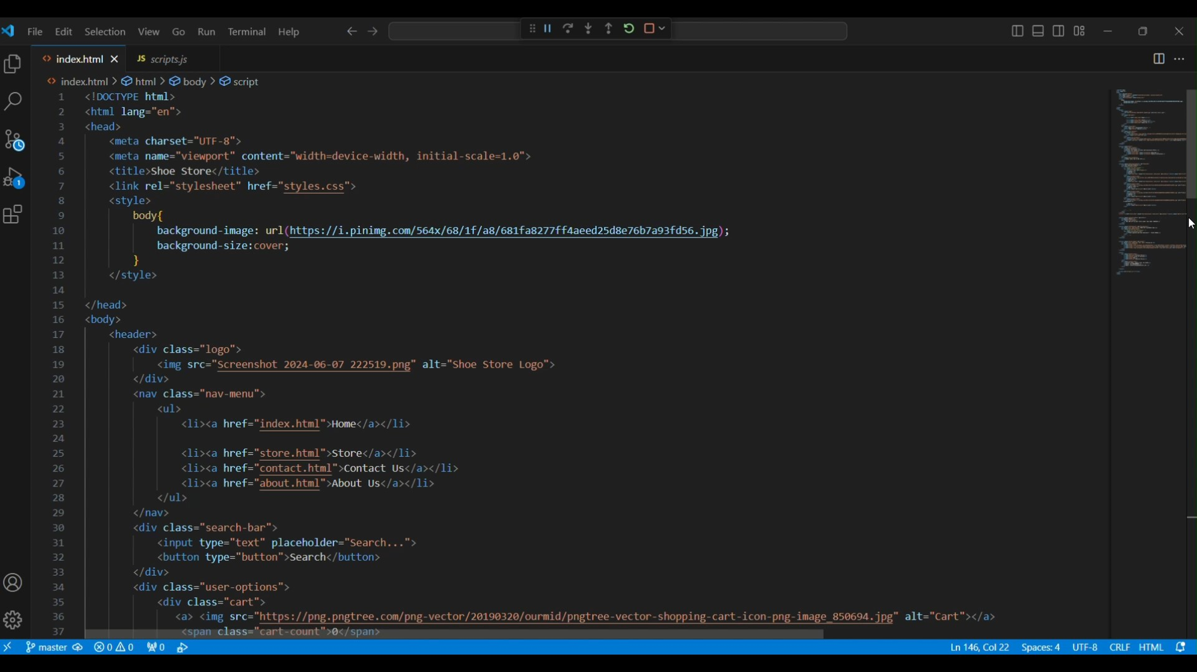

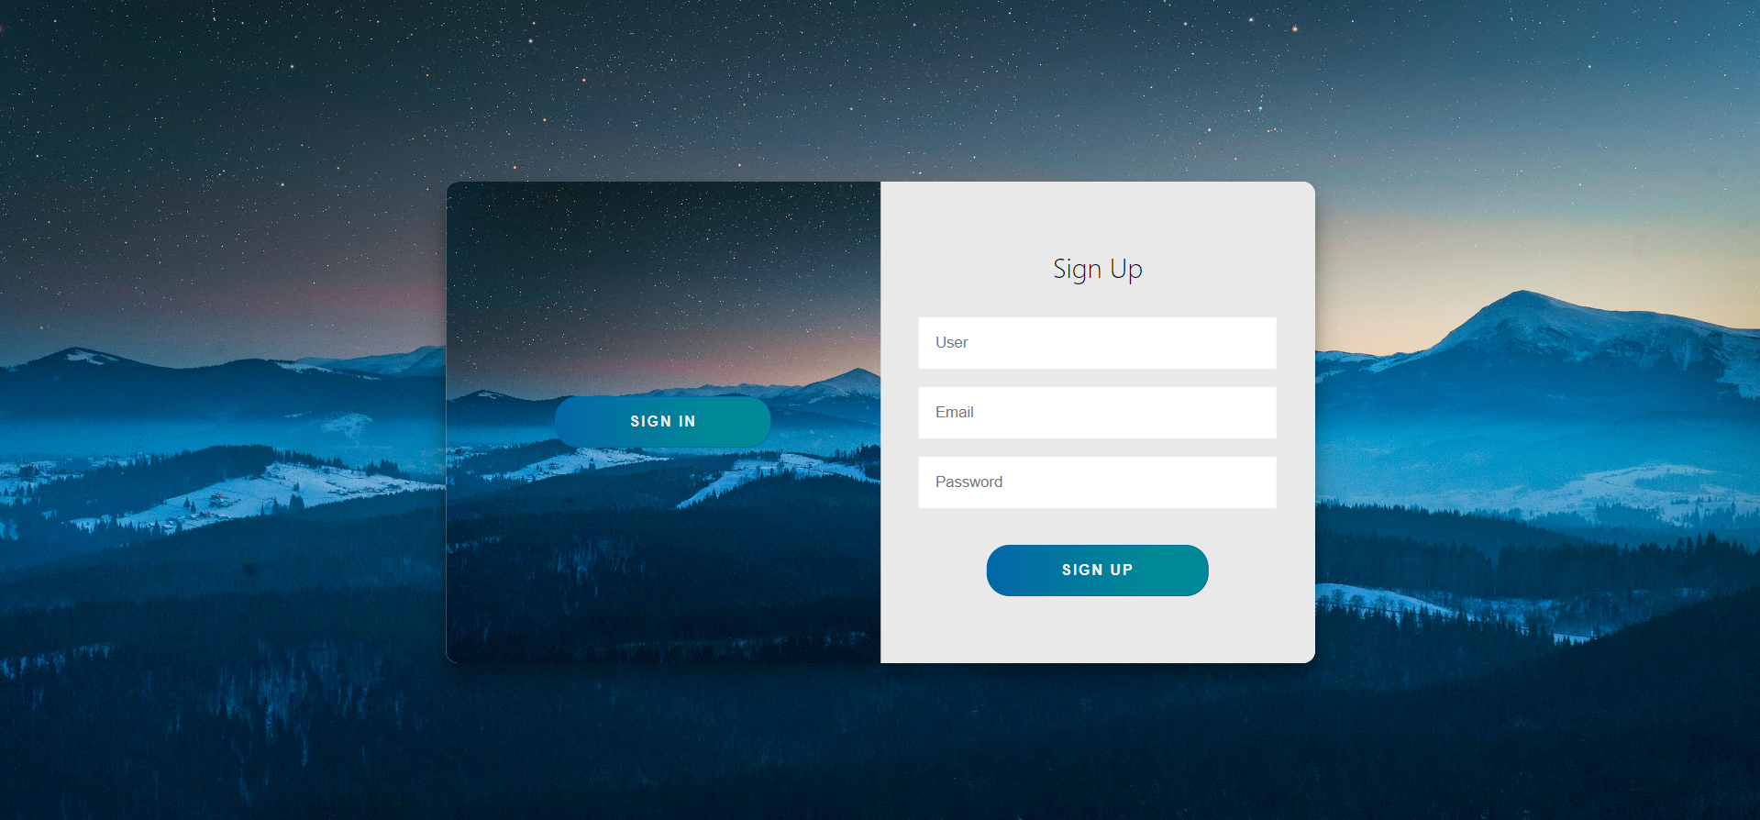

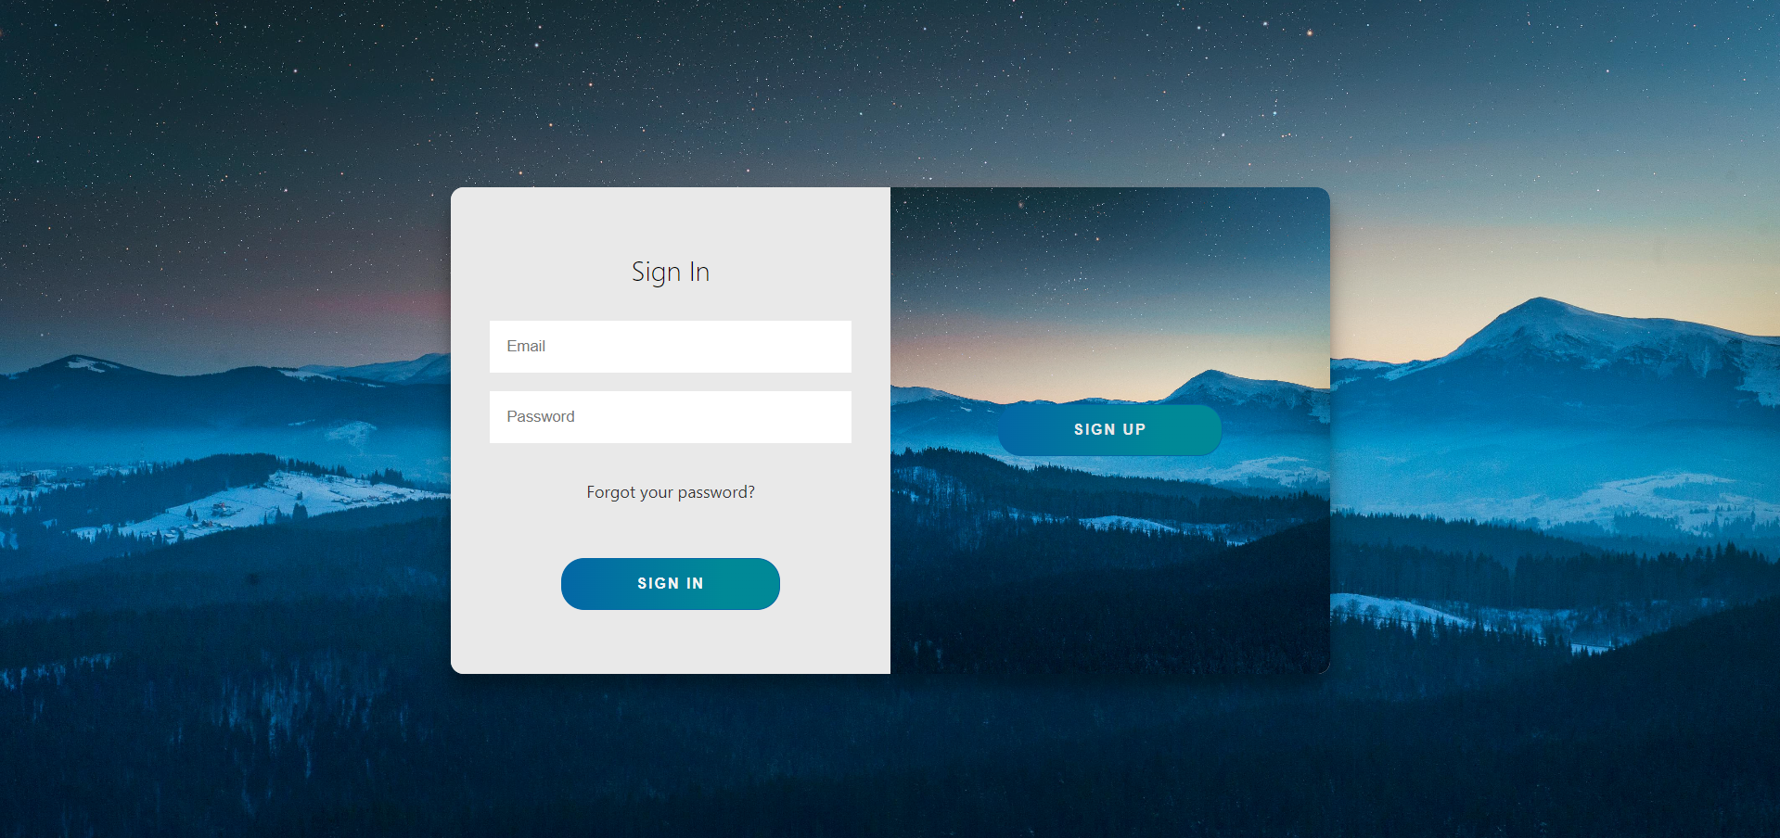

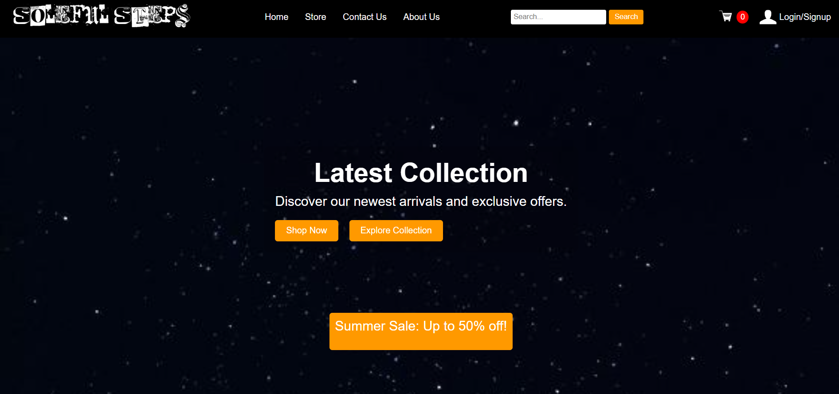

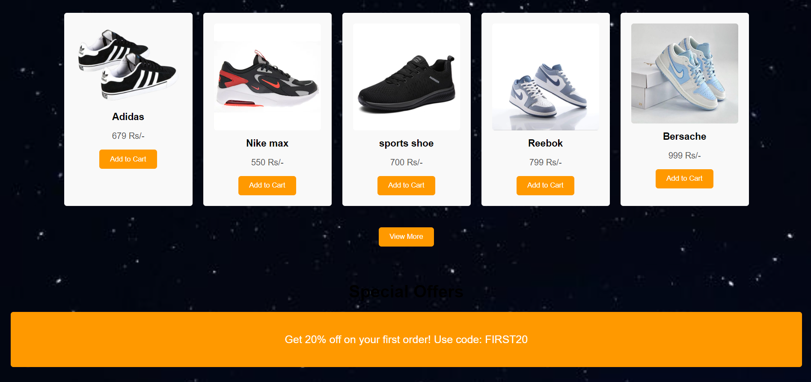



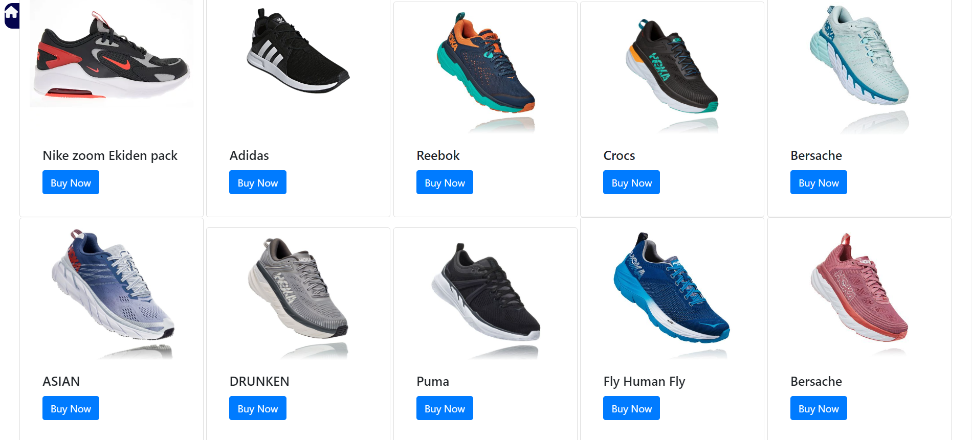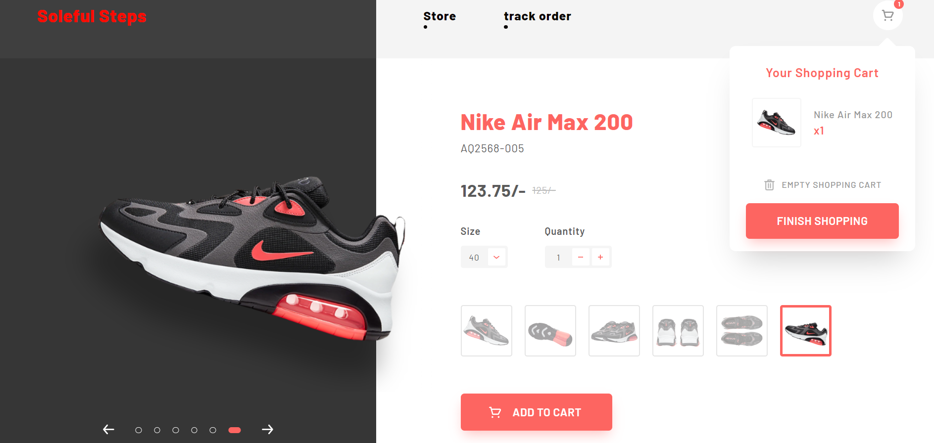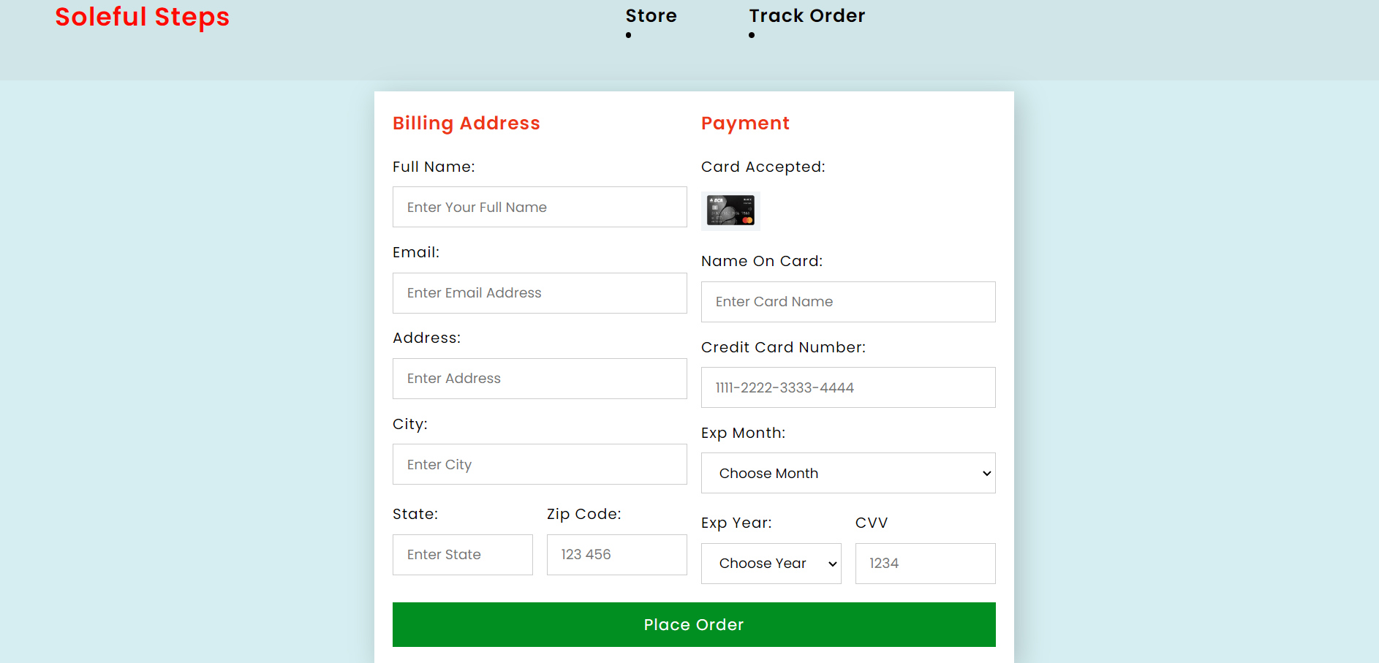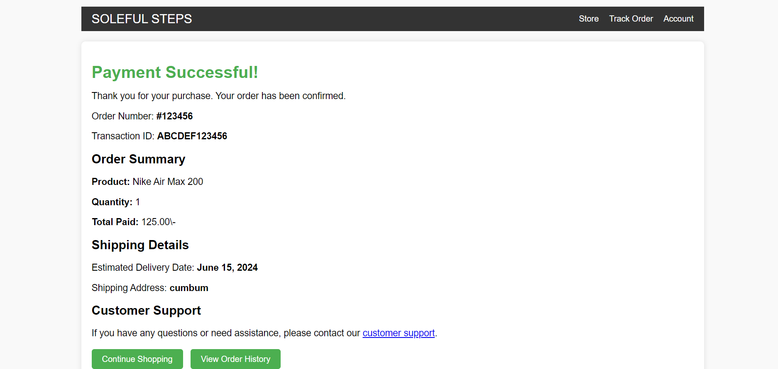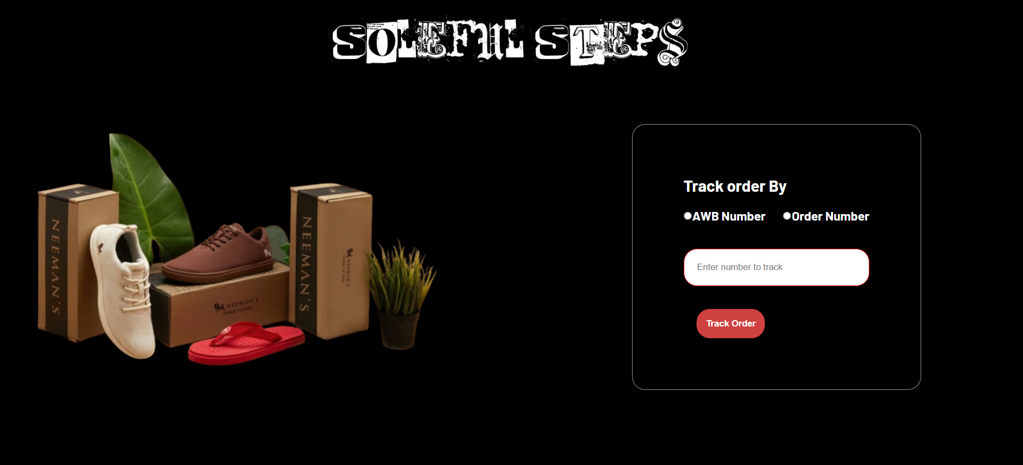

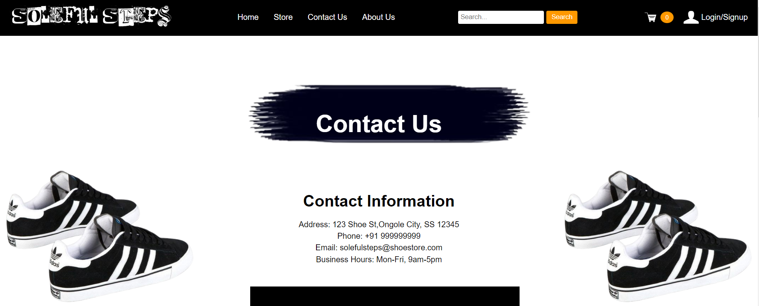

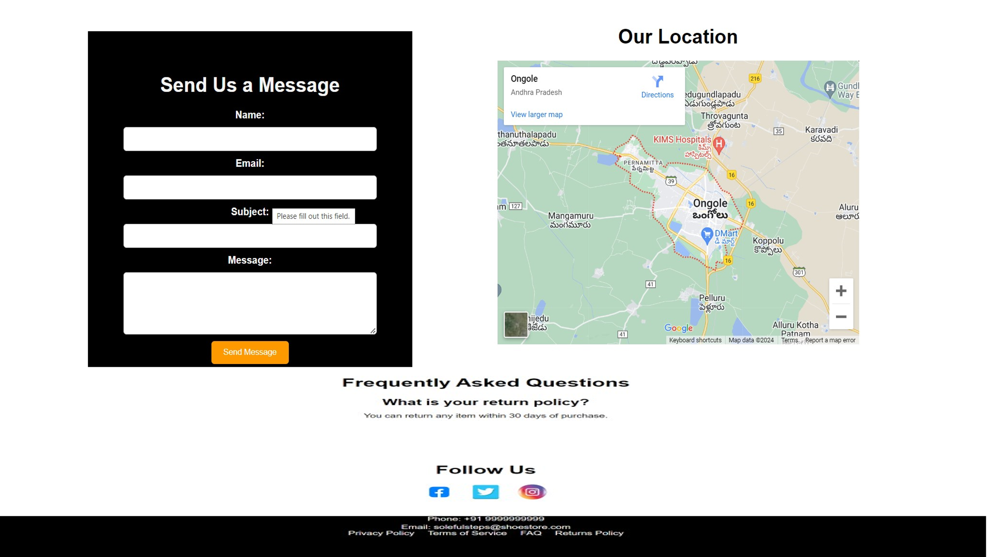

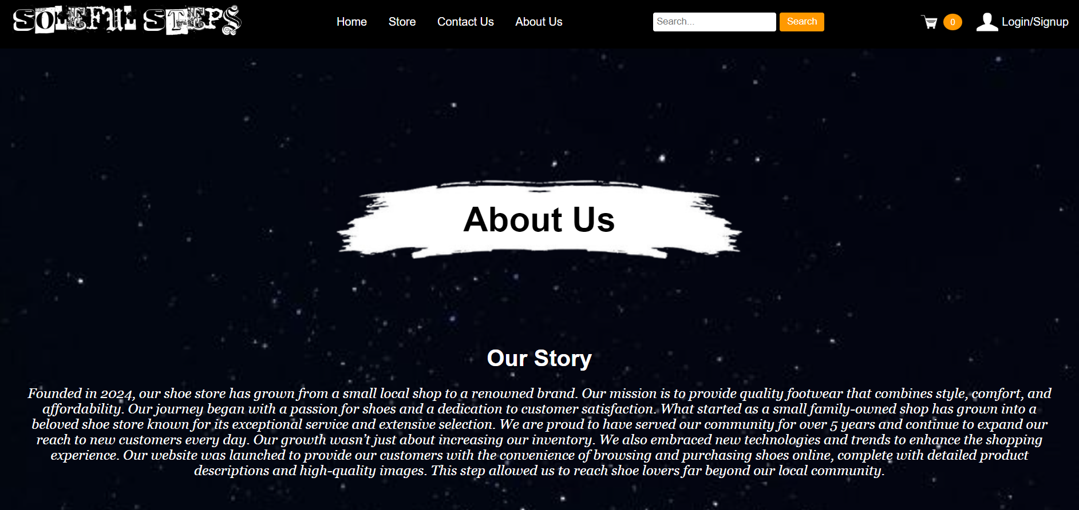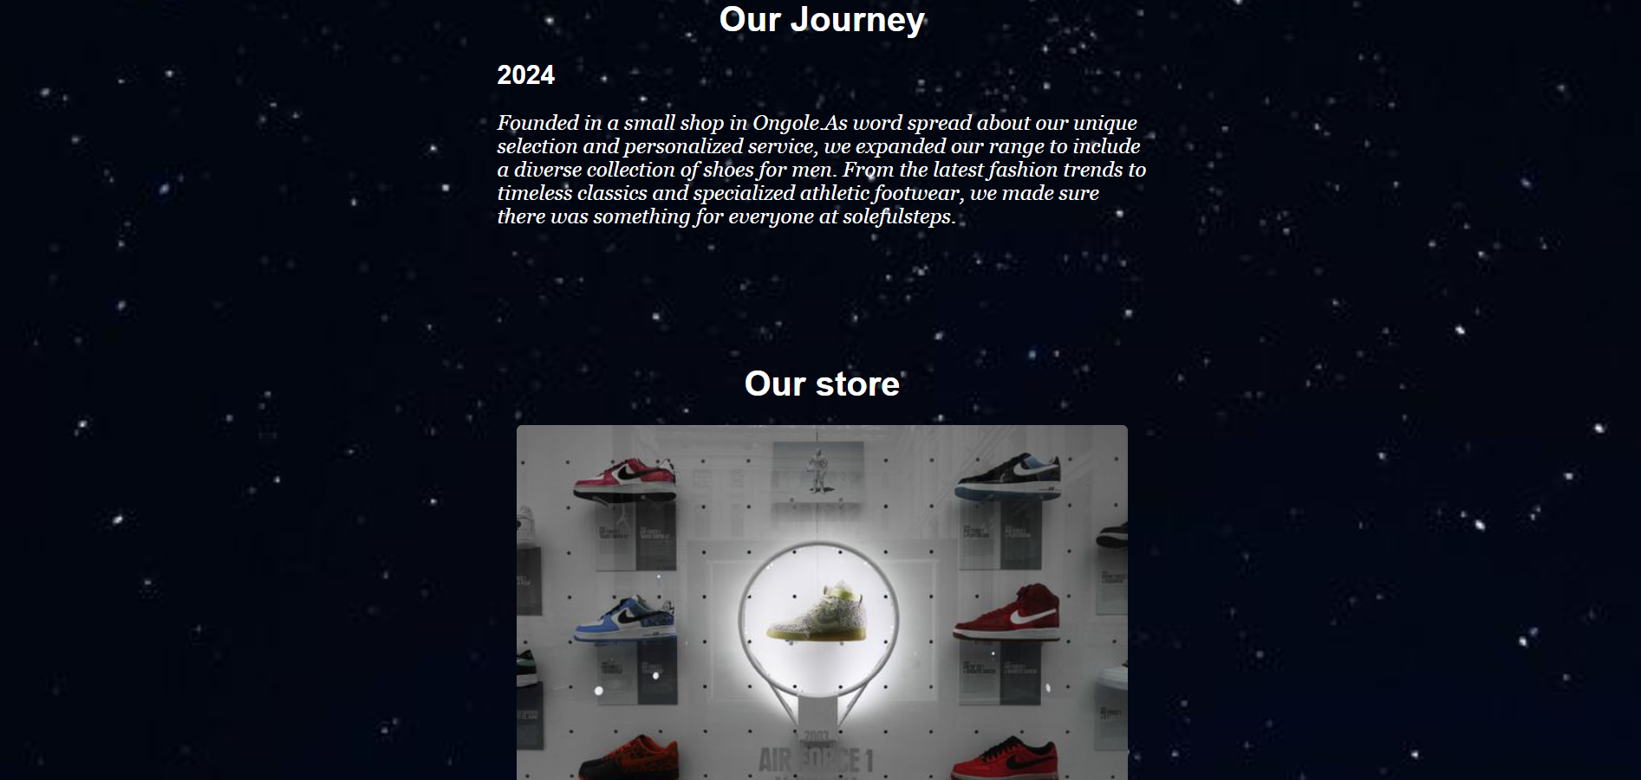

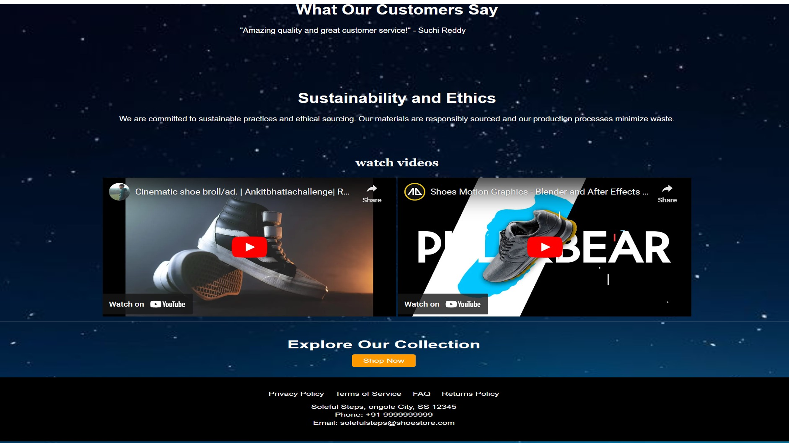1**. Increased Market Share**

Soleful Steps' meticulous approach to market research and strategic supplier partnerships positions the store for substantial growth in market share. By delving deep into customer preferences, trends, and competitive analysis, Soleful Steps gains invaluable insights that inform its product selection and marketing strategies. Through partnerships with reputable shoe manufacturers and distributors, the store secures a diverse range of high-quality footwear, ensuring it meets the demands of its discerning clientele. As a result, Soleful Steps anticipates capturing a larger share of the local footwear market, establishing itself as the premier destination for quality shoes in Ongole.

2**. Higher Customer Satisfaction**

Customer satisfaction lies at the heart of Soleful Steps' business philosophy. By prioritizing the customer experience through personalized service, seamless shopping experiences, and responsive support, the store aims to elevate satisfaction levels among its clientele. Expertly trained staff provide tailored recommendations and assistance, fostering a welcoming and accommodating atmosphere that resonates with customers. With a focus on exceeding expectations at every touchpoint, Soleful Steps anticipates an increase in repeat business, positive word-of-mouth referrals, and overall customer satisfaction.

3. **Improved Brand Awareness and Loyalty**

Through targeted marketing campaigns, community engagement initiatives, and consistent branding efforts, Soleful Steps seeks to enhance brand awareness and foster lasting brand loyalty. By effectively communicating its unique value proposition and differentiating itself from competitors, the store aims to carve out a distinctive identity in the minds of consumers. Active participation in local events, sponsorships, and partnerships further solidifies Soleful Steps' presence within the community, reinforcing its brand image and fostering strong connections with customers. As a result, the store anticipates increased brand recognition, customer loyalty, and market visibility.

4**. Optimized Inventory Management**

Soleful Steps' commitment to optimized inventory management enables it to meet customer demand effectively while minimizing stockouts and excess inventory. Through the implementation of robust inventory management systems and data-driven forecasting techniques, the store maintains optimal stock levels and product assortment. By closely monitoring sales trends, customer preferences, and market dynamics, Soleful Steps ensures it offers the right mix of products to meet the diverse needs of its clientele. As a result, the store anticipates improved operational efficiency, reduced costs, and enhanced customer satisfaction.

5**. Enhanced Online Presence and Sales Growth**

In today's digital age, an online presence is crucial for business success. Soleful Steps' strategic investments in digital marketing, e-commerce platforms, and omnichannel retail strategies position it for significant growth in online sales. By leveraging targeted marketing campaigns, search engine optimization (SEO), and social media engagement, the store expands its customer reach beyond the local market, driving overall revenue growth. Seamless integration between online and offline channels provides customers with a seamless shopping experience, further boosting sales and enhancing brand visibility.

6. **Positive Social Impact and Corporate Responsibility**

Soleful Steps is committed to making a positive impact on society and the environment. Through sustainable and ethical business practices, the store seeks to minimize its environmental footprint and contribute positively to the communities it serves. By incorporating eco-friendly packaging, fair labor standards, and charitable initiatives, Soleful Steps demonstrates its corporate social responsibility and aligns with the values of socially conscious consumers. As a result, the store anticipates enhanced brand reputation, increased customer loyalty, and a greater sense of purpose among its stakeholders.

7. **Continuous Improvement and Adaptation**

Continuous improvement lies at the core of Soleful Steps' business strategy. By regularly measuring performance, analyzing data, and soliciting feedback from customers and stakeholders, the store identifies areas for improvement and adapts to changing market dynamics. A culture of innovation and agility enables Soleful Steps to stay ahead of competitors and capitalize on emerging opportunities. By embracing change and fostering a learning mindset, the store remains flexible, resilient, and responsive to evolving customer needs and market trends.

In conclusion, through its strategic approach to market expansion, customer satisfaction, brand building, and corporate responsibility, Soleful Steps anticipates achieving sustainable growth, fostering customer loyalty, and making a positive impact on its stakeholders and the communities it serves.

**5.Conclusion**

Soleful Steps stands at the intersection of style, comfort, and community, poised to make a lasting impact in the footwear industry and beyond. As we reflect on our journey thus far and look to the future, it's clear that our commitment to excellence, innovation, and customer satisfaction will continue to drive our success and shape our legacy.

* Online shopping is the best way to purchase any item but be careful because there may be some fake products on different sites.
* Only purchase those products which can be easily recognized.
* Purchase only from trusted applications like our product.

1. **A Journey of Passion and Purpose**

Founded in 2024 in the vibrant city of Ongole, Soleful Steps was born out of a shared passion for footwear and a vision to redefine the shoe shopping experience. From our humble beginnings, we've remained steadfast in our dedication to offering quality shoes that not only look good but also feel good, empowering our customers to step into confidence and style with every stride.

2**. Building a Brand, One Step at a Time**

At the heart of Soleful Steps is a commitment to building a brand that resonates with customers on a deeper level. Through strategic marketing initiatives, community engagement efforts, and a relentless focus on customer satisfaction, we've worked tirelessly to establish ourselves as a trusted destination for footwear enthusiasts. Our brand is more than just a logo or a tagline – it's a reflection of our values, our aspirations, and our unwavering dedication to excellence.

3. **Nurturing Relationships, Fostering Community**

Central to our success has been the strong sense of community that we've cultivated among our customers, employees, and partners. From the moment you step into our store, you're not just a customer – you're part of the Soleful Steps family. Whether it's through personalized service, engaging events, or charitable initiatives, we're committed to fostering meaningful connections and making a positive impact in the lives of those we serve.

4. **Embracing Innovation, Driving Growth**

As we look to the future, we remain firmly focused on innovation and growth. Our dedication to continuous improvement drives us to embrace new technologies, explore emerging trends, and adapt to changing market dynamics. Whether it's through expanding our online presence, diversifying our product offerings, or enhancing our sustainability efforts, we're committed to staying ahead of the curve and delivering value to our customers.

5. **A Vision for the Future**

As we conclude this chapter of our journey and embark on the next, our vision for Soleful Steps remains clear: to be the premier destination for quality footwear, where style meets comfort, and community thrives. We're excited to continue pushing the boundaries of what's possible, inspiring confidence and self-expression in every step along the way.

In closing, we extend our heartfelt gratitude to our loyal customers, dedicated employees, and supportive partners who have been instrumental in our success. Together, we've achieved remarkable milestones, but our journey is far from over. With passion, purpose, and perseverance as our guiding principles, we look forward to the next chapter of Soleful Steps and the many adventures that lie ahead.

"In conclusion, Soleful Steps epitomizes the fusion of passion, purpose, and perseverance in the footwear industry. From our inception in 2024, we've endeavored to redefine the shoe shopping experience, offering quality footwear that not only looks good but also feels good. Our commitment to excellence, innovation, and customer satisfaction has propelled us forward, building a brand that resonates with customers on a deeper level. As we look to the future, our vision remains clear: to be the premier destination for quality footwear, where style meets comfort, and community thrives. With the unwavering support of our loyal customers, dedicated employees, and valued partners, we're excited to embark on the next chapter of our journey, inspired by the endless possibilities that lie ahead.".

In conclusion, the journey of Soleful Steps embodies a commitment to excellence, innovation, and community. Since our establishment in 2024, we've strived to redefine the shoe shopping experience, offering quality footwear that blends style, comfort, and durability. As we reflect on our achievements and look to the future, we remain dedicated to our core values and vision for growth.

Moving forward, our focus on expansion and market penetration, enhanced digital presence, sustainability initiatives, and product innovation will drive our strategic direction. By staying agile, responsive, and customer-centric, we're poised to achieve continued success and make a positive impact in the footwear industry and beyond.

As we embark on this journey of growth and transformation, we extend our sincere gratitude to our loyal customers, dedicated employees, and valued partners who have been instrumental in our success. Together, we look forward to stepping into the future with confidence, inspired by the endless possibilities that lie ahead.

Thank you for being part of our story.

Sincerely,

Valella supritha

Founder & CEO, Soleful Steps

**6.Future Work**

As Soleful Steps continues to grow and evolve, our focus on innovation, sustainability, and community engagement remains steadfast. Looking ahead, we outline key areas of future work that will shape our strategic direction and drive our continued success.

* The project made here is just to ensure that this product could be valid in today’s challenging world.
* Currently it is not visible on the virtual world (Internet) due to some limitations of the project.

In future it may be available to users

1. **Expansion and Market Penetration**

One of our primary objectives for the future is to expand our reach and penetrate new markets. While we've made significant strides in establishing ourselves as a premier destination for footwear in Ongole, we recognize the opportunity for further growth and expansion. Through strategic market analysis and careful planning, we aim to identify new target demographics and geographic regions where we can introduce Soleful Steps to a broader audience. Whether it's through opening new physical stores, expanding our online presence, or exploring partnerships with other retailers, our goal is to extend the Soleful Steps brand to new markets while maintaining the same level of excellence and customer satisfaction that has defined us thus far.

2. **Enhanced Digital Presence and E-commerce Innovation**

In an increasingly digital world, the importance of an enhanced digital presence cannot be overstated. As such, a key focus area for future work is the continued optimization and innovation of our e-commerce platform. We recognize the need to continually adapt and evolve in response to changing consumer preferences and technological advancements. This includes investing in advanced website functionalities, mobile optimization, and user experience enhancements to ensure a seamless and intuitive shopping experience for our online customers. Additionally, we aim to leverage data analytics and machine learning algorithms to personalize recommendations, streamline the checkout process, and improve overall customer satisfaction. By staying at the forefront of e-commerce innovation, we aim to drive continued growth in our online sales channel and cement our position as a leader in the digital retail space.

3. **Sustainability Initiatives and Corporate Social Responsibility**

As stewards of the environment and responsible members of the community, Soleful Steps is committed to integrating sustainability initiatives and corporate social responsibility (CSR) into our business practices. In the coming years, we plan to expand our efforts in this area, focusing on reducing our carbon footprint, minimizing waste, and supporting social causes that align with our values. This includes exploring opportunities to source sustainable materials, adopt eco-friendly manufacturing processes, and implement recycling and waste reduction programs throughout our supply chain. Additionally, we will continue to engage with local communities through charitable partnerships, volunteer initiatives, and educational programs aimed at making a positive impact on society. By incorporating sustainability and CSR into our core business strategy, we aim to not only reduce our environmental impact but also inspire positive change and foster greater social cohesion within the communities we serve.

4**. Innovation and Product Development**

Innovation has always been at the heart of Soleful Steps, and we remain committed to pushing the boundaries of what's possible in the footwear industry. In the years to come, we will continue to invest in product development and innovation, with a focus on creating innovative, trend-setting designs that resonate with our customers. This includes exploring new materials, technologies, and manufacturing processes to enhance the performance, comfort, and style of our footwear offerings. Additionally, we will actively seek out collaborations with designers, artists, and influencers to bring fresh perspectives and creative ideas to our product lineup. By staying ahead of the curve and embracing a culture of innovation, we aim to delight our customers with exciting new offerings that exceed their expectations and solidify our reputation as a leader in the footwear market.

**Conclusion :**

As Soleful Steps looks to the future, our commitment to excellence, innovation, and community remains unwavering. By focusing on expansion and market penetration, enhancing our digital presence, prioritizing sustainability and CSR, and fostering a culture of innovation, we are poised to achieve continued success and make a positive impact in the years to come. With the support of our loyal customers, dedicated employees, and valued partners, we are excited to embark on this journey of growth and transformation, inspired by the endless possibilities that lie ahead.